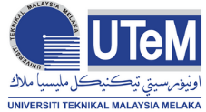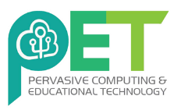

**“Learn some tools, skills and strategies to Grad on Time!”**

**Day 1: Online Research Tools**

This workshops will help postgraduate students and encourage students to take responsibility for finishing their degrees on time by equipping them with some tools, skills and strategies to assist them endeavor.

**Who should Attend?**

Postgraduate Students (PHD/Master), Academia etc.

**Payment Method:**

Account Name : BENDAHARI UTEM

Account Number: 04042010000833

Bank Name : BANK ISLAM MALAYSIA

**For Further Information:**Ts. Dr. Siti Nurul Mahfuzah Mohamad  
Pusat Pembelajaran Sepanjang Hayat,  
Universiti Teknikal Malaysia Melaka  
013-3808211 | [mahfuzah@utem.edu.my](mailto:mahfuzah@utem.edu.my)

<https://goo.gl/PtyfCE>

**POSTGRADUATE SKILLS**

**DEVELOPMENT PROGRAMME**

23-27 September 2019 | UTeM